Turn Radius Report

UTA Racing

Osama Almasri

Samatar Samatar

Tayden Carter

George Kallam

Sarbagnya Bhattarai

1/29/2025

**Steering Wheel vs Wheel Angle Test**

The circumference of F16s steering wheel was marked every 10-degrees. The 0-reference mark and pointer were aligned at the top of the steering wheel while the wheels were aligned straight ahead. This is shown in Fig. 1 below. Next, the steering wheel was turned from its centered position at 10-degree intervals until full lock was achieved. Considering this approach the upscale, a downscale measurement was also performed similarly from full lock back to the centered position.

These measurements were taken at each of the front wheels. However, this was performed only in the direction of turning that would cause the measured wheel to be the outside wheel of a turn. This gives us plots of the steering wheel angle vs wheel angle for either front tire, if it's the tire on the outside of the turn.

**Figure 1. Steering Wheel with Indicator and Degree Lines**

For the wheel, a large straight metal plate was placed on the side of the left wheel as seen in Figure 2. A string of yarn was placed against the plate and was taped down to the floor. With the car wheels facing forward, the first piece of string represented a 0-degree wheel angle. Next, the driver turns the steering wheel to the left with one tick mark correlating to 10-degree steering angle. The metal plate is then picked up and placed to line up against the now-turned wheel. The string is aligned to the metal plate and tapped down. The process of turning the wheel, placing the metal sheet to serve as a straight edge for the string which will eventually measure the wheel angle. A complete representation of the array of springs are seen in Figure 3 This is repeated until the left wheel is turned fully to the right until it locks.

Once the lock had been reached a high-quality photo was taken to measure the many strings of yarn using the Digital Image Correlation method (DIC); which will be used to measure the wheel angle. After the picture is taken remove the tape and strings to conclude the upscaling measurements. Ultimately this will show the correlation between the steering angle from the steering wheel to the wheel angle from the strings on the ground. Now to begin the downscaling process the wheel is turned back to its initial position, but while placing the metal plate and taping string at each increment.  Once this is complete, take the photo that will be used for DIC for downscaling. Now repeat this same process for the right wheel making a left turn for both upscale and downscale.

**Figure 2. Metal Plate Alignment**

**Figure 3. Wheel Angle String Placement**

**Turn Radius Calculation**

To calculate the turn radius, we needed a few measurements from the car such as the Wheelbase (WB) and the Front Track Width (TF). The following equation is used to calculate the turn radius of the outer wheel given the wheel angle . We took measurements of the steering angle and the wheel angles on the way from 0 to 100 degrees and from 100 degrees back down to 0. We did these upscale and downscale measurements on both turning directions to help negate the error. An average was calculated for the wheel angle based on the average of the upscale and downscale measurements of both the left and right wheel.

(1)

In Eq. (1) is the equation we used to calculate the turn radius, and the wheel angle is associated with a steering wheel angle input. With the above equation and the wheel angle measurements taken from the car we can calculate the range of the turn radius for both left and right. The Wheelbase for F16 is 66” along with the Front Track Width being 49.5” and Eq. (1) accounts for the values being in inches and converts the output to feet.

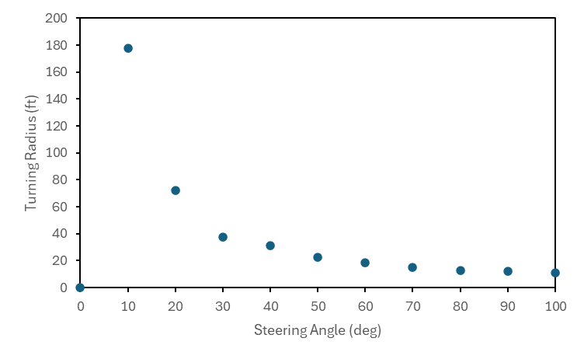

**Figure 4. Left Wheel Steering Angle vs Turn Radius**

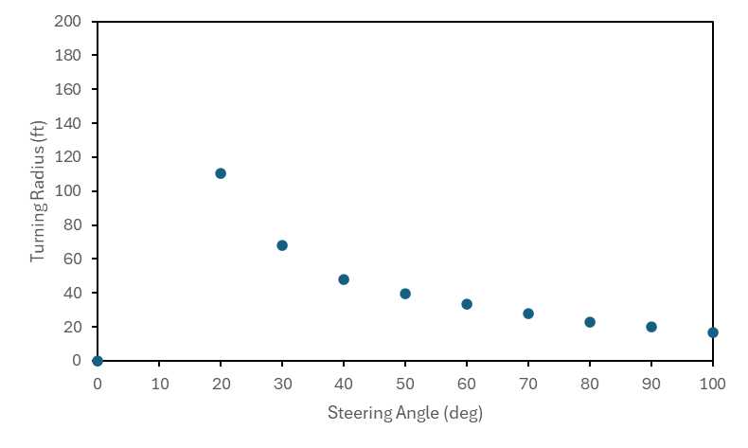

**Figure 5. Right Wheel Steering Angle vs Turn Radius**

The plots above show the steering angle and the turn radius at that steering angle, it was calculated using the wheel angle which was measured above. Figure 4 shows the left wheel steering angle vs turn radius and Fig. 5 shows the right wheel steering angle vs turn radius. In Fig. 6 and Fig. 7 we see the plots before we accounted for the error and took the average of those wheel angles.

**Figure 6. Upscale/Downscale Plot of Left Wheel**

**Figure 7. Upscale/Downscale Plot of Right Wheel**

**Results/Conclusions**

During data collection, it was noticed that the steering wheel and shaft had a noticeable amount rotational and translational free play. This was noted to be around 5 to 10 degrees of steering wheel rotation and is confirmed when comparing the upscale vs downscale curves of each plot. The plots show a turn radius for full lock steering wheel input of 10.4 ft when turning left and 11.4 ft when turning right. These numbers appear reasonable but should be checked against what is measured on the car.

**Appendix**

**Table 1. Steering Angle with Turn Radius**

|  |  |  |  |  |
| --- | --- | --- | --- | --- |
| Steering Angle | Left Wheel Angle | Right Wheel Angle | Left Turning Radius  (ft) | Right Turn Radius (ft) |
| 0 | 0 | 0 | 0.00 | 0.00 |
| 10 | 1.6 | 1.9 | 194.84 | 163.73 |
| 20 | 4.1 | 4.4 | 74.67 | 69.42 |
| 30 | 8.1 | 7.7 | 36.58 | 38.62 |
| 40 | 10.11 | 8.8 | 28.78 | 33.47 |
| 50 | 13.4 | 11.6 | 21.02 | 24.73 |
| 60 | 16.1 | 14 | 16.99 | 20.00 |
| 70 | 18.4 | 17.3 | 14.47 | 15.60 |
| 80 | 21 | 19.2 | 12.27 | 13.73 |
| 90 | 21.8 | 20.5 | 11.69 | 12.65 |
| 100 | 23.7 | 22.2 | 10.47 | 11.41 |

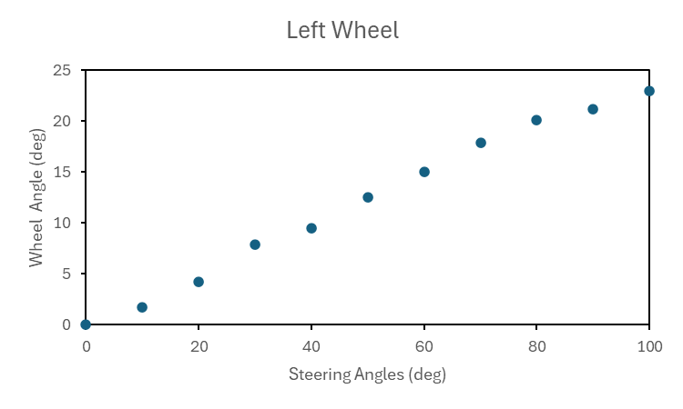

**Figure 8. Left Wheel Steering and Wheel Angle Plot**

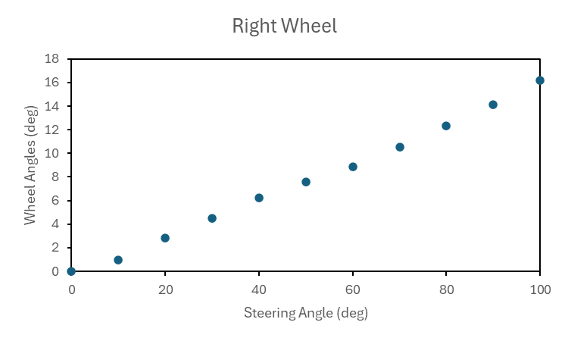

**Figure 9. Right Wheel Steering and Wheel Angle Plot**

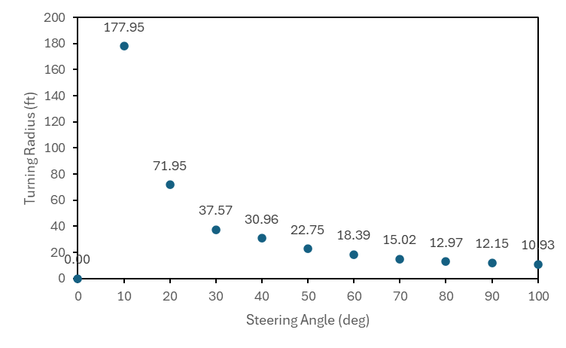

**Figure 10. Left Wheel Steering with Turn Radius and Data Points**

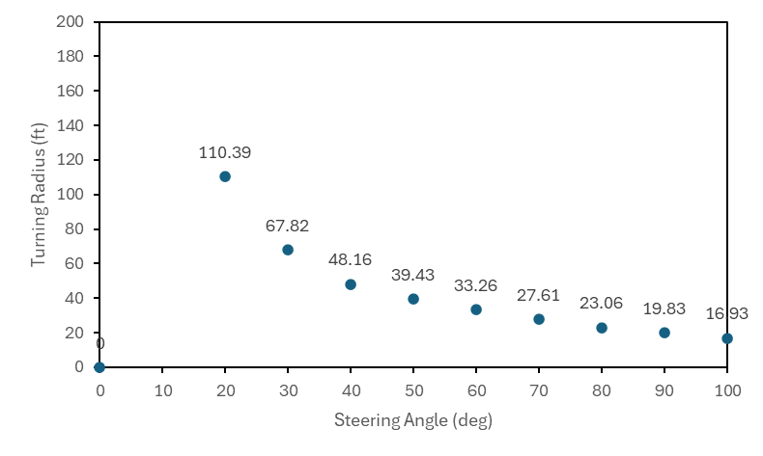

**Figure 11. Right Wheel Steering with Turn Radius and Data Points**